Guid 136

* 136.1 | UNIQUEIDENTFIER  
  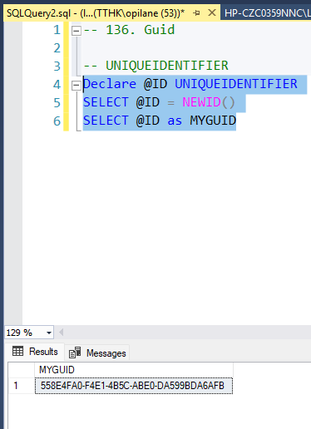
* 136.2 | USADB  
  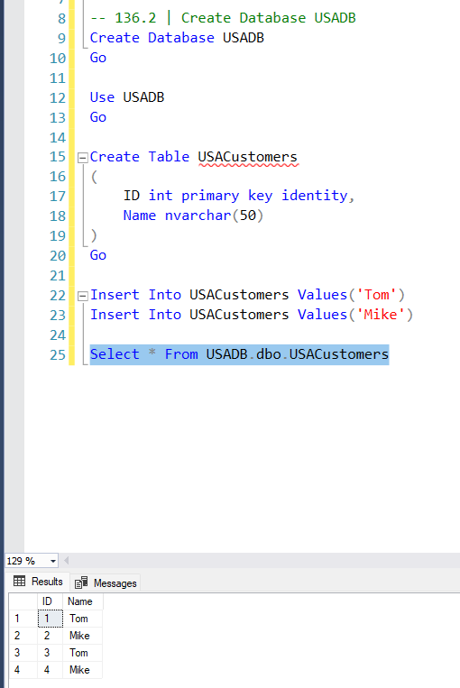
* 136.3 | IndiaDB  
  